SCUBA-2 Block Specification
Readout_card

Created on: 4 October 2005
Last saved on: 05 October 2005
Table of Contents

1. Block Description 3
1.1 Block Hierarchy 3
1.2 Block Overview and Features 3
1.3 Detailed Description 3
2. Interface Description 5
2.1 Signals Description 5
Files Associated with this Block 7

Block Description
This is the top-level block in the hierarchy of the RTL-level code for the readout-card FPGA.

Block Hierarchy
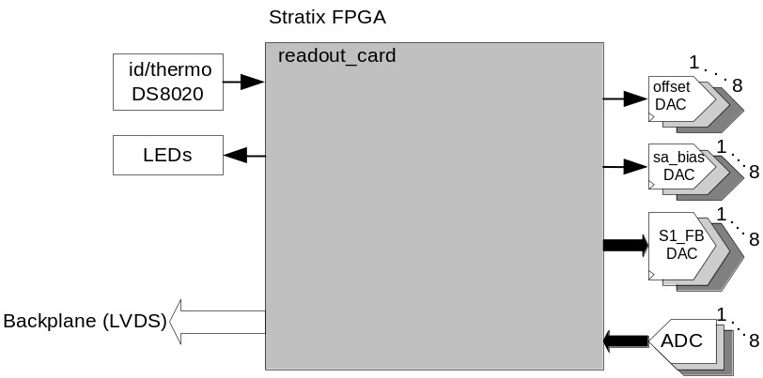
Figure 1

Block Overview and Features
The readout card top level interfaces to the external devices including the data sampling ADC, the parallel DAC to control S1_FB, and the SPI DACs to control the offset and bias of the series array (sa_bias and sa_offset).

Detailed Description
The following blocks are instantiated in readout_card block:
- flux_loop :
  - Instantiates 8 separate instances of the flux_loop_ctrl block, one for each channel. The flux_loop_ctrl controls the ADC and determines the data that has to be applied to the S1_FB DAC depending on the mode of operation. There are three modes of operations: lock mode (with PIC controller), ramp mode and constant mode. Depending on the data mode settings, the appropriate data is delivered on the wishbone bus.
  - Handles all the flux_loop-related wishbone commands
  - Instantiates an fsfb_corr block to handle flux-jumping for all 8 channels in lock mode
- frame_timing:
  - This block controls the overall timing and ensures the coherence of the operations of the different blocks.
- dispatch:
  - Receives and decodes the incoming backplane commands
  - Delivers the wishbone-formatted command to the appropriate wishbone slave
  - Converts the wishbone reply to backplane format and transmits the reply over the backplane.
For more information, refer to the documentation for each block.
flux_loop
flux_loop_ctrl ch1
flux_loop_ctrl ch2
flux_loop_ctrl ch3
flux_loop_ctrl ch4
flux_loop_ctrl ch5
flux_loop_ctrl ch6
flux_loop_ctrl ch7
flux_loop_ctrl ch8
wbs_frame_data
wbs_fb_data
frame_timing
fsfb_corr
dispatch
readout_card

Figure 2: Readout_card Block Diagram
The following block diagram shows the more detailed view of the flux_loop_ctrl block instantiated for each channel:
DAC
frame_timing
ADC
wbs_frame_data
wbs_fb_data
flux_loop_ctrl
fsfb_ctrl
pidz
+
filter
const
ramp
fsfb_proc
fsfb_Q_bank1
fsfb_Q_bank0
filtter_Q
filter_regs
fsfb_calc
io_ctrl
adc_sample_coadd
sa-bias_ctrl
offset_ctrl
SPI
DAC
SPI
DAC
fsfb_corr
Figure 3: Flux_loop_ctrl Block Diagram

Interface Description

Signals Description
 | Description | Direction
Global Signals
rst_n | Global reset signal | In
inclk | PLL input clock | in
ADC Interface (X 8 for ADC1 to ADC8)
adc1_dat | ADC1 14-bit digital data | in
adc1_ovr | ADC1 over-range bit | in
adc1_rdy | ADC1 data ready signal | in
adc1_clk | ADC1 Encode signal, conversion initiated on rising edge | out
Feedback DAC Interface (X 8 for DAC1 to DAC8)
dac_FB1_dat | Feedback DAC1 14-bit data | out
dac_FB_clk | Feedback DAC clock (common to DAC1 to DAC8) | out
Offset and SA_Bias DAC Interface
dac_ dat | 8-bit data for DAC1 to DAC8, each bit is the serial data for the SPI DAC shared between the sa_bias and offset DACs | out
dac_clk | 8-bit-wide clock for DAC1 to DAC8, each bit is the clock for the SPI DAC shared between the sa_bias and offset DACs | out
bias_dac_ncs | 8-bit wide chip select for DAC1 to DAC8, each bit is the chip select for the sa_bias SPI DAC | out
offset_dac_ncs | 8-bit wide chip select for DAC1 to DAC8, each bit is the chip select for the offset SPI DAC | out
LVDS Interface
lvds_cmd | receives incoming commands over the backplane LVDS line. The backplane signal is a multi-drop signal that originates from clock card and goes to all the cards. | in
lvds_sync | incoming sync signal over the backplane LVDS line | in
lvds_spare | connected to a spare backplane LVDS line for future use | in
lvds_txa | used to transmit the reply to a command over a backplane LVDS line. The backplane line is a dedicated line between readout card and clock card. | out
lvds_txb | connected to a spare backplane LVDS line for future use. The backplane line is a dedicated line between readout card and clock card. | out
TTL Interface (X 3 for TTL1 to TTL3 spare lines)
ttl_dir1 | controls the direction of the spare TTL line | out
ttl_in1 | input of the TTL spare line | in
ttl_out1 | output of the TTL spare line | out
LED Interface
red_led | Red LED data | out
ylw_led | Yellow LED data | out
grn_led | Green LED data | out
Miscellaneous
dip_sw3 | dip switch 3 data | in
dip_sw4 | dip switch 4 data | in
wdog | watchdog | out
slot_id | 4-bit data hard-wired per slot on the backplane | in
card_id | single-wire interface to the on-board ds8020 id/temperature chip | in
mictor | 32-bit data for the logic analyzer | out

Files Associated with this Block

File | Description
readout_card.vhd | top-level
readout_card_pack.vhd | pack file for readout_card.vhd including definition of some of the constants
packet.hex | used to emulate backplane-format commands in conjunction with tb1_readout_card.vhd and clk_card.vhd
tb1_readout_card.vhd | testbench for readout_card top-level
clk_card.vhd | top-level clock card instantiated in tb_readout_card.vhd in order to issue the backplane formatted commands.  In CVS, refer to the branch called: rc_v1_firmware_validation.

